**ERINNYA: GLOBAL MONETARY ALLOCATIONS TO EVERYONE, BEING, AND NATURE (ESTIMATED TO BE ALIVE OR NOT), BULI KKAMPUNI OBA EKIBIINA OBA EKIBIINA OBA OMULIMU GWA**

**990,000,000/- BULI LUNAKU (OBUKADDE MWENDA N'OMWENDA BULI LUNAKU) OBA SSENTE ENDALA BULI LUNAKU KU BULI EMU MU NSI YONNA**

**ENDAGIRIRO:**

**NAMBA YA KKAMPUNI:**

**DISTRICT ETUUZIZZA KKAMPUNI ENO:**

Biwandiikiddwa nga 3/12/2024

**Article 1: Abaatandikawo**

Abaatandikawo

1. Dorothy Namuyiga, yazaalibwa nga 10/11/1974, abeera mu Belgium
2. ;;;;;;
3. ,,,,,,,
4. Amusa Oluwaseki

**Ekitundu 2: Erinnya, ffoomu n'endagiriro**

Enzikiriza eno ye **GLOBAL MONETARY ALLOCATIONS TO EVERYONE, BEING, AND NATURE (ESTIMATED TO BE ALIVE OR NOT), BULI KKAMPUNI OBA EKIBIINA OBA EKIBIINA OBA OMULIMU GWA**

**990,000,000/- buli lunaku (obukadde mwenda n'omwenda buli lunaku) OBA ssente endala buli lunaku ku buli emu mu nsi yonna**

Enkola y'amateeka ng'ekibiina ekikolagana n'obuvunaanyizibwa obutono etwala obuvunaanyizibwa bwayo bwe buno:

Obuvunaanyizibwa bwaffe kwe kwewaayo ssente. Bu yüzden her bir örnek ve satıcıları yazarlık ya da kağıtlarda aldık. Laba eby'okwesalirawo A ne B wansi w'ekitundu kino.

Buli lunaku buli omu ategeeze munne ekigendererwa kyaffe n'obuvunaanyizibwa bwaffe.

Tewali kusosola kwesigamiziddwa ku kkomo ng'ab'eŋŋanda zo bwe bakugamba, kwe kugamba: langi y'olususu, olulimi olwogerwa, obulemu, ensibuko, eggwanga, okusigala oba obutabeerawo, n'ebiwandiiko oba ebitalina, okukwatagana n'ekitundu kyonna, ekigendererwa ky'okukola oba obutakola, ekigendererwa ky'okusigala oba obutakola, okuyitamu oba okusigala, okufa oba obutazuukusa, obulwadde oba nedda, obutabeerawo oba okubeerawo, okunoonya amagezi oba nedda, okunoonya okujjuza emmeeza zo oba nedda, okugezaako okuyiiya ssente zo oba nedda.

Tujja kugoberera emisingi gy'endagaano z'okukola buli lunaku, okuyimirira oba obutakola, okukola endagaano oba obutakikola, nga tumanyi nti tetusobola kukaka muntu yenna kusenguka oba okutambula naddala abatandikawo, abakulembeze nga bwe tulina ekigendererwa ky'ensi yonna.

Obuvunaanyizibwa bwaffe eri abo abaweebwa, buli omu mu kika kye, bukoma ku kwogera n'okuddamu okuwandiika, buli w'awandiika, ssente eziweebwa omwaka, era zino buli mwaka emirembe gyonna. Ebigambo byonna eby'okubuzaabuza omuntu ku byobugagga by'enkolagana eno ng'agaana okuwandiika lisiiti z'omuntu (okugabana ng'owandiika amaanyi mu mpagi y'okufuna n'okukozesa kwalyo mu mpagi ey'okufuluma okusasula wonna w'obeera) bitwalibwa ng'ebitalina mugaso. N'olwekyo, buli muntu ajja, k'abe muntu yenna, k'abe kkampuni oba omukugu mu by'obusuubuzi oba ow'emikono, alina okusooka okubeera n'ekitabo eky'okuwandiika buli mwaka. Buli omu ku mmwe tumutegeeza buli w'obeera nti olina okuyingiza ssente z'ogaba buli lunaku mu kiwandiiko kyo eky'ekitundu era osobola okuwumbawumbako lisiiti omulundi gumu n'emyaka gyonna okwewala okuddayo okufuna amagezi n'amagezi. N'olwekyo, ssente zino ziweebwa buli muntu, ku buli butonde, n'olwekyo ziba 990,000,000/- buli lunaku (obukadde mwenda n'omwenda buli lunaku) (Obukadde mwenda n'omwenda) buli lunaku.

Ekigambo Etal ku bifaananyi by'ensimbi z'ogenda okulaba kitegeeza "abantu abalala n'obutonde n'ebitonde n'ebitonde ebyaliwo mu kiseera ky'olubuto lwayo oba ekigendererwa".

Jjangu omulundi gumu mu mwaka oba emirundi egiwerako okutegeka n'okukyusakyusa oba ebiseera byonna okusomesa n'okutegeka n'okukubaganya ebirowoozo.

1. Akakodyo 1 okufuna n'okusasula: Oyingira nga mu mmeeza oluvannyuma lwa layini eno. Kozesa ekitundu kya "Pay" buli omu okusasula munne.

|  |  |  |  |  |
| --- | --- | --- | --- | --- |
| **Obungi bw'ebiwandiiko** | **Bye Bye Dating** | **Funa 990,000,000/- buli lunaku oba mu bufunze omwaka oba emyaka** | **Pay by writing with seller in front of me or on the other end of the phone or messages here effectively** | **Nnyonnyola ekituufu ekifunibwa oba ekigulibwa oba ekitundibwa okufuna** |
|  |  |  |  |  |
|  |  |  |  |  |

1. Akakodyo 2 okufuna n'okusasula: Tegeka ku kintu kyonna ssente ezaafunibwa oba okusasulwa nga bwe kiri mu kifaananyi, ka kibe mu langi oba enzirugavu n'enjeru oba ku lupapula n'okozesa nga ssente entuufu ng'okozesa omuwendo ne ssente ezaalondebwa. Laba ekifaananyi eky'ekyokulabirako oluvannyuma lw'okukola enkola eno.

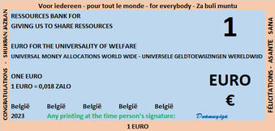

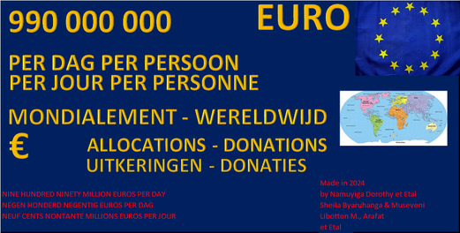

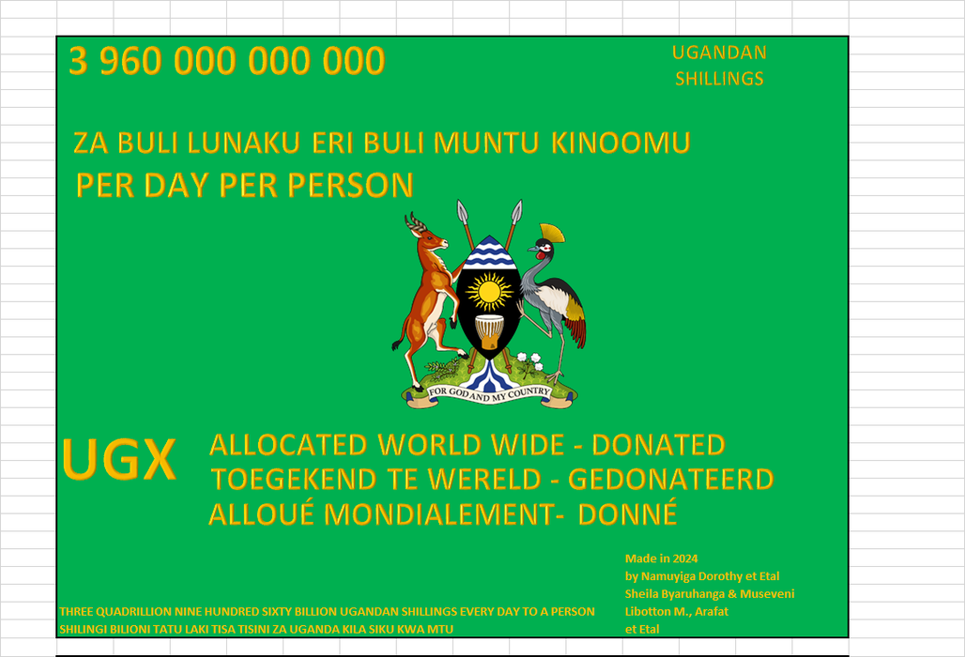

**Ekitundu 3: Ensimbi n'okugabana emigabo**

Leero nga December 3, 2024, 990,000,000/- buli lunaku (obukadde mwenda n'omwenda buli lunaku) (obukadde mwenda mu mwenda) buli lunaku era ssente zino zijja kuddibwamu emirembe gyonna ssente eziweebwa kkampuni eno nga bwe kiri eri kkampuni zonna mu nsi yonna. Ekibuga ekikulu si kya muntu yenna kubanga ssente za bwereere ezikolebwa mu langi oba mu langi enzirugavu ku lupapula A4 buli lunaku oba okuwandiikibwa mu kitabo wansi w'ekitundu "Funa 990,000,000/- buli lunaku (obukadde mwenda n'omwenda buli lunaku) BULI lunaku ng'owandiika mu kitongole kino".

Ekibuga ekikulu kigenda kukolebwa kkampuni yaffe oba kigenda kubeera kuwandiika oba okutegeka nga kisinziira ku nkola ya ofiisi ng'okukozesa ebipande, okukola ebigambo, okuyingiza ebifaananyi, okukuba ku lupapula A4, okumanya ennamba n'ennimi. Capital evudde mu ndowooza y'amazima g'ebyenfuna n'ebitongole okwewa obuyinza obw'okugula ate wano ng'okozesa obukodyo obwogeddwako waggulu wansi w'ekitundu 3 eky'amateeka gano. Olw'endowooza y'okwewa amaanyi ag'okugula, tukozesezza omukutu gw'okunoonyereza ku bungi obulungi ng'ensimbi ze tusobola okwewa buli lunaku ng'omuntu ow'obutonde (eyazaalibwa oba eyatondebwa oba okubeerawo oba okulabika) mu nsi yonna. Ssente mmeka eza buli lunaku ezisaanira kkampuni oba ekibiina ky'abakozi oba ekibiina ky'ebyenfuna, ekintu kyonna ng'ensi yonna oba omuntu eyeekolera yekka? Eky'okuddamu kyaffe ekyafunibwa mu 2022 okuva mu kuwuliriza ebirowoozo by'abantu b'ensi yonna ebikkirizibwa wano nga tusalawo abanoonyereza, abakozi bannakyewa, abakugu, abaana, ebisolo, ebimera, Katonda, emyoyo, abeenyigira mu nsonga eziteekebwa wano olwo 990,000,000/- buli lunaku (obukadde mwenda n'omwenda buli lunaku) (Obukadde mwenda n'omwenda) buli lunaku era ssente zino zijja kuddibwamu emirembe gyonna era ensi yonna. Enteekateeka za ssente za buli kkampuni zigenda kukola ebigendererwa byazo era ffe ezaffe tuzigaba mu nsi yonna ku muwendo gwa 990,000,000/- buli lunaku (obukadde mwenda n'omwenda buli lunaku) (obukadde mwenda n'omwenda) buli omu gw'aganyulwamu. Emiganyulo eri abaganyulwamu tegiva mu ssente eziweebwa kkampuni eno buli lunaku, giva mu pulaani ez'enjawulo ze tulina okuyiga nga bwe tugenda mu maaso. Ssente zino za kukulaakulanya bizinensi eno.

Ekibuga kino ekikulu kigenda kuweebwa mu buwandiike, n'olwekyo ssente ziwandiikibwa mu bitundu mu ngeri yonna.

Obuyinza bwaffe obw'okuyiiya n'okwewa ebyo ebiyitibwa ssente eziweebwa buli kkampuni mu nsi yonna buva ku kubeerawo mu butonde, okubeera omuntu, ekitonde ekikola ebirowoozo n'obukugu ne Katonda n'abantu abali mu mukwano. Okumanya okusoma y'obukugu obwa bulijjo obw'okusoma n'okuwandiika n'okuyiiya n'okwogera oba okwogera mu ngeri yonna.

Ebyobugagga byaffe biva mu ssaayansi w'okubeerawo kubanga Katonda atuwa. Mu nkola ey'enjawulo, tuzigabana okuyitira mu maduuka oba mu maka g'abantu abatunda ebintu byabwe. Tetwagala kulemererwa n'olwekyo tulina okukozesa ebyo ebituweebwa okutuuka ku ssente zino ffenna era wano tuzzaayo omugabo gwaffe ogwa buli lunaku. Tulindirira amaduuka ag'enjawulo okutuguza ebyobugagga byabwe eby'enjawulo nga tukyusa mu liveries ez'ebitundu.

Tujja kusasula buli mbeera nga ofiisi z'omusolo, ebiwandiiko bya kkampuni, ofiisi z'obwannakyewa n'abaguzi nga tuyita mu mpapula zaffe nga bw'ozalaba nga zikubiddwa mu langi oba enzirugavu n'enjeru.

Olw'obumanyirivu bwe tulina mu bya bbanka n'ebyenfuna, tujja kuzuula ebifo ebisanyukirwamu ssente okwetooloola ensi yonna okugeraageranya ebifaananyi byabwe, emyaka mingi, okuyiga okuyiiya bwe tuba tetusobola. Era tukimanyi nti ebyokulabirako mu bbanka ne ssente biva mu bantu. Yani kimseyi rahatsızmedik.

Tusigala mu bizinensi eno emirembe gyonna.

Eky'okulabirako wano ng'ensimbi eza buli lunaku ezitegekeddwa ggwe ne kkampuni yaffe era nti tuziwa ffe n'abantu abalala bonna nga tuwumbawumbako nga tukubisaamu ennaku n'omwaka oba emisana ekisinga obuzibu. Ssente zonna ziri mu Excel nga zituuse okukubisa buli muntu ku ssente zino eza langi, empapula, ebisale by'entebe zaffe mu kuwaayo. Okulindirira okuwaayo ssente zo okuva mu pulaani endala oba okukikola wekka. Kino kwe kumalawo obwavu (ennyinnyonnyola y'okujjuza y'eno: Okukola ebbala, obutali bumativu, obutakkaanya, n'ebirala, okusaanawo ng'okola ebintu ebyetaagisa oba enkyukakyuka, ng'okola ebintu ebisaana)





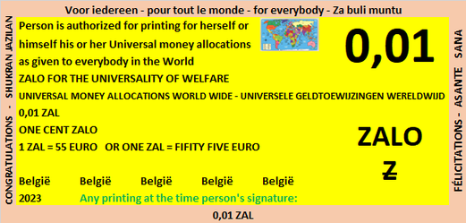

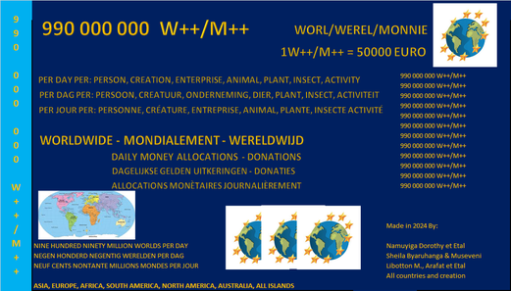

**Ekitundu 4: Ekigendererwa n'Okutuukiriza**

Kino kye kiruubirirwa n'engeri y'okutuukirizibwamu.

1. Kola ekibuga kyaffe ekikulu n'ebintu byonna.
2. Yogera ku kibuga kyaffe ekikulu eri omuntu yenna.
3. Buli muntu afaayo n'ayagala okwetooloola ensi yonna muwe ssente 990,000,000/- buli lunaku (obukadde mwenda n'omwenda buli lunaku) oba okuwumbawumbako kwayo (ng'ogattako 990,000,000/- buli lunaku (obukadde mwenda n'omwenda buli lunaku) omuwendo x (emirundi) ogw'ennaku n'emyaka) mu ngeri yonna oba engeri y'okusasula eyaliwo oba eyatondebwa.

Abaweebwa ssente zino ye muntu yenna, obutonde bwonna mu bika byayo, obulamu bwonna (ng'ekiwuka, ensolo, ebinyonyi, ekimera) oba omuntu atali mulamu (ng'ensi ku buli mmita 30, amazzi ku buli mmita 100, amayinja ku ttani 2000) n'ekigendererwa ky'okutuukiriza ssente oba okusasula buli ssente z'osasula mu lunaku oba omwezi oba omwaka oba ebbanga.

1. Wandiika 990,000,000/- buli lunaku (obukadde mwenda n'omwenda buli lunaku) okusobola okukozesa eno ng'engeri y'okusasulamu ate nga tewali ngeri ndala yonna mu kiseera ekituufu oba ssente endala eziwandiikibwa okuyitira mu ngeri gye tulina tewali buvunaanyizibwa bwa kulabika ng'omuzimbi omulala.
2. Okuteekawo ssente n'ensimbi ennyingi nga "ZALO", Worl-Werel-Monnie n'ekigendererwa ky'okuzikozesa ng'engeri y'okusasula ssente n'obutalemesebwa olw'ebbula lino.

Ebyokulabirako bino wammanga: Ebifaananyi bino wammanga bijja kulabika nga ssente ze tukozesa ku lupapula nga tukozesa ebifaananyi.

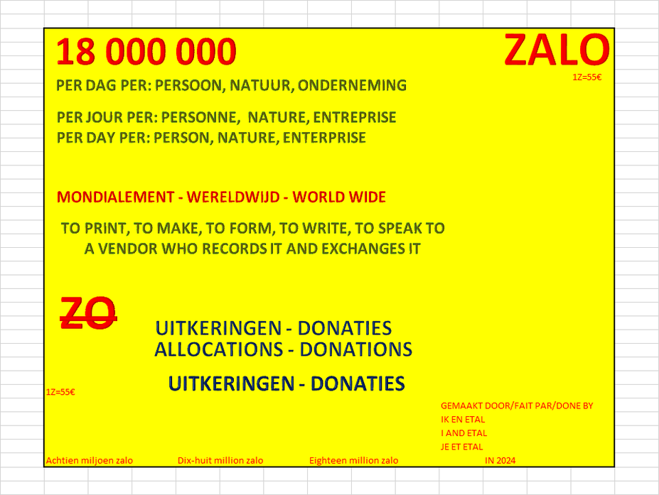





1. Olw'okwagala kwaffe, buli muntu mu nsi yonna asobola okuyiiya ku kintu ky'ayagala oba ky'ayagala ng'agattako omuwendo, erinnya lya ssente ly'ayagala oba ly'ayagala ka libeere nga likozesebwa oba terinnakozesebwa (kino kitegeeza nti liyiiya erinnya n'etutegeeza ku ofiisi z'ebibiina bino okukyusa) n'erinnya lyayo ery'enjawulo oba siginecha awamu n'ensi.
2. Teeka ebitabo oba empapula oba ebintu mu mpagi ng'engeri y'okufuna n'okusasula buli omu eri munne. Kino kikolebwa mu buwandiike nga kasitoma oba omusuubuzi w'emirimu n'ebintu oba kasitoma oba oyo aweebwa ssente zino ng'ayingiza ssente z'alina okufuna oba ez'okusasula mu kitundu ekisaanira.
3. Wano wammanga waliwo emmeeza entonotono naye empanvu nnyo mu myaka nga tewali muwendo gwayongeddwa kubanga kwe kufuna oba okusasula, si kwewolereza kugula oba okutunda, wabula okuwolereza okusasula ssente z'ogula oba okutunda. N'olwekyo ekifaananyi kyayo kijja kulaga ekiggyibwa mu ssente eziyingira n'okufuluma oba ssente oba ebiwandiiko byaffe wano n'ekigendererwa ky'okusasula bannaffe, ka kibe nze oba ekirala.

|  |  |  |  |  |
| --- | --- | --- | --- | --- |
| **Obungi bw'ebiwandiiko** | **Bye Bye Dating** | **Funa 990,000,000/- buli lunaku oba mu bufunze omwaka oba emyaka** | **Pay by writing with seller in front of me or on the other end of the phone or messages here effectively** | **Nnyonnyola ekituufu ekifunibwa oba ekigulibwa oba ekitundibwa okufuna** |
|  |  |  |  |  |
|  |  |  |  |  |

Ebyo ebijja okulabika mu bitabo okukozesa okusooka okufuna ku 990,000,000/- buli lunaku (obukadde mwenda n'omwenda buli lunaku) oba ssente endala n'okukozesa okusasula ekintu kyonna mu dduuka oba ku muguzi yenna. Laba emmeeza egenda okukolebwa okusobola okufuna ebiwandiiko ebijja eri omukuumi w'ebitabo mu mannya ge era n'addamu okusasula ssente z'okufulumya oba okugula ebintu ebikolebwa omutwe gwe gumu ogw'ekitabo oba ekibiina kye oba kkampuni ye.

**Ekitundu 5: Ekiseera ky'omulimu guno**

Ku ofiisi ez'obwereere ejja kumala essaawa zaayo eziraga buli lunaku.

**Ekitundu 5: Olukiiko Olukulu:**

Zibeerawo buli mwezi.

Publish on 30 April of each year or before if the day is not working, the annual accounts of Belgium in summary and taking into account that the populations around Belgium have each received 990,000,000 euro per day (nine hundred and ninety million euros per day) x 365 days. Ve deliver'u zero ile kah ka

Tufaayo nnyo ku fiizi eri omuntu oba obutonde oba okubeera nti ofuna 990,000,000/- buli lunaku (obukadde mwenda n'omwenda buli lunaku) x ennaku 365 omwaka guno era ebyo bye byonna.

**Ekitundu 6: Buli muntu n'obutonde oyinza kumusasula otya?**

Tujja kusasula nga tukozesa ebintu ebiyinza okukozesebwa era ebiyinza okutundibwa ng'okujjuza ekiwandiiko kyo naffe oba emmeeza yo ku ntandikwa. Tetugenda kukuwerekera ku musuubuzi wabula osobola okujja n'omusuubuzi nga buli omu asobola okuyingiza ebivaamu oba ebiyingizibwa mu kitongole ekituufu okumaliriza okugula kwo oba okutunda ne munno. Bw'otuuka wano, weetegereze ssente ezaafunibwa we ziyingira ne ssente ezisasulwa we ziyingira, era eyo y'ensasula eri munno

**Ekitundu 7: Abakulembeze**

Okusinziira ku baagala engeri gye bakolamu endagaano. Tuli ba dizayina n'abagaba. Oyo yenna ayagala okutuyamba ajja kututuukirira.

Tukola pulaani era tusobola okukyusa ebifaananyi ne bannaffe mu nsi yonna.

Abalala balina okuteeka emirimu gyabwe mu nkola okusobola okutuukiriza buli kigendererwa buli lunaku mu nsi yonna.

**Ekitundu 8: Badayirekita**

Tutandikira ku eyo eriwo naddala mu kiseera kino ne Dorothy Namuyiga. Namuyiga Dorothy bw'aba talina bannansi, alina okuweebwa ssente za Public Social Allowance Center emirembe gyonna.

Emirimu gyonna egy'ebika eby'enjawulo gikkirizibwa okukola n'okwesasulira nga beeyiiya 900/- buli lunaku olw'emirimu gyabwe, okuteekawo ekiwandiiko ky'omusaala n'okusasula ssente z'abantu n'okuggyawo emisolo gy'omuntu.

Obuweereza bwaffe bugula 5/- buli kiwandiiko okuva ku ntandikwa okusinziira ku katale.