**NAME: GLOBAL MONETARY ALLOCATIONS TO EVERYONE, BEING, AND NATURE (ESTIMATED TO BE ALIVE OR NOT), EACH COMPANY OR ASSOCIATION OR GROUP OR ACTIVITY OF**

**990,000,000 EURO PER DAY (NINE HUNDRED AND NINETY MILLION EUROS PER DAY) OR OTHER CURRENCIES PER DAY TO EACH ONE WORLDWIDE**

**ADDRESS:**

**COMPANY NUMBER:**

**DISTRICT OF REGISTRATION:**

Written on: 3/12/2024

**Article 1: The founders**

The founders

1. Dorothy Namuyiga, born on 10/11/1974, domiciled in , Belgium
2. ;;;;;;
3. ,,,,,,,
4. Non-profit representative

**Article 2: Name, legal form and address,**

The denomination is **GLOBAL MONETARY ALLOCATIONS TO EVERYONE, BEING, AND NATURE (ESTIMATED TO BE ALIVE OR NOT), EACH COMPANY OR ASSOCIATION OR GROUP OR ACTIVITY OF**

**990,000,000 EURO PER DAY (NINE HUNDRED AND NINETY MILLION EUROS PER DAY) OR OTHER CURRENCIES PER DAY TO EACH ONE WORLDWIDE**

The legal form as a limited liability cooperative takes its responsibilities as follows:

Our responsibility is to give ourselves allowances. So we pay each instance and supplier either in writing on their side or received on paper and that's it. See options A and B under this article.

Inform each other every day about our purpose and responsibility.

There is no discrimination based on limitations as your relatives tell you, namely: skin color, language spoken, disability, origin, nationality, stay or not, with or without papers, affiliation to any part, intention to work or not, intention to stay or not, passage or stay, death or not or resuscitating, sick or not, absent or present, looking for advice or not, looking to fill in your tables or not, trying to design your coins or not.

We will follow the principles of contracts for work day by day, stop or not, contracting or not, knowing that we cannot force anyone to move or travel, especially the founders, administrators as we have the global intention.

Our responsibility towards the recipients, each in his or her own category, is limited to verbalizing and repeating for his or her writing, wherever he or she writes, the amounts allocated for the year, and this every year eternally. Any claim to ruse one's attributions for the assets of this cooperation by refusing to write for one's receipts (allocation by writing force in the column of receiving and its use in the exit column for payment anywhere) is considered null and void. Therefore, each receiver who comes along, whether he is an individual, or a company or a liberal or commercial or artisanal profession, must first of all have a notebook for writing for each year. We inform each of you wherever you are that you are obliged to enter your monetary allocation allocated daily in your columned notebook and that you can summarize the receipt once and for all years so as not to come back for advice and advice. This amount allocated to you as allowances to everyone, to each nature, to each being is therefore 990,000,000 euros per day (nine hundred and ninety million euros per day) (Nine Hundred and Ninety Million Euros) per day.

The word Etal on the images of the coins you will see means "other people and natures and creatures and beings present at the time of its conception or intended".

Come for once a year or several times to organize and exchange or all times to educate and design and exchange with each other.

1. Option 1 to receive and pay: You enter it as in the table after this line. Use the "Pay" column for each payment to each other.

|  |  |  |  |  |
| --- | --- | --- | --- | --- |
| **Numbering of entries** | **Dating entries** | **Receive my 990,000,000 euros per day or are summary of the year or years** | **Pay by writing with seller in front of me or on the other end of the phone or messaging here effectively** | **Describe what is actually received or bought or sold to receive** |
|  |  |  |  |  |
|  |  |  |  |  |

1. Option 2 to receive and pay: Design on any material the amount received or to be paid as in the image, whether it is in color or black and white or on a piece of paper and use it as real currency with the amount and currency chosen. See the exemplary image after this formulation.

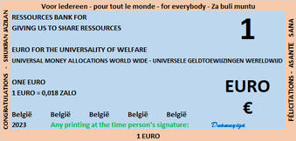

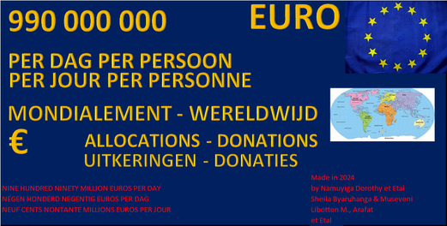

**Article 3: Capital and distribution of shares**

Today, December 3, 2024, 990,000,000 euro per day (nine hundred and ninety million euros per day) (Nine Hundred Ninety Million Euros) per day and this amount will be repeated eternally is the capital allocated to this company as to all companies worldwide. The capital does not belong to anyone because it is a free allowance made in color or black and white printing on A4 paper daily or written in a book under the column "RECEIVE 990,000,000 euros per day (nine hundred and ninety million euros per day) PER DAY BY WRITING IN THIS COLUMN".

The capital is to be designed by our company or will be writing or design based on office techniques such as use of spreadsheets, word processing, image insertion, printing on A4 paper, knowledge of numbers and languages. Capital comes from the ideology of economic facts and institutions to give oneself purchasing power and here using the aforementioned techniques under Article 3 of these statutes. Thanks to the ideology of giving oneself purchasing power, we have used the channel of research on the ideal amount as a daily income that we can give ourselves as a natural person (born or created or simply existing or appeared) worldwide. How much daily income is ideal for a company or an association or economic group, anything as globally or for a self-employed person? Our response obtained in 2022 from listening to the suggestions of the world's populations adopted here by decision of researchers, volunteer workers, professionals, children, animals, plants, Gods, spirits, participants that are actually put here is then 990,000,000 euro per day (nine hundred and ninety million euros per day) (Nine Hundred and Ninety Million Euros) per day and this amount will be repeated eternally and for the whole world. The designs of the currencies belonging to each company will provide for their purposes and we for ours to distribute them all over the world at the rate of 990,000,000 euros per day (nine hundred and ninety million euros per day) (nine hundred and ninety million euros) per day to each beneficiary. The benefits to the beneficiaries do not come from the daily allowances to this company, they come from the separate designs to be learned as we go along. This capital is for the development of this enterprise.

This capital is to be received in writing, so money written in columns in any way.

Our authorization to design and give ourselves what are called monetary allocations to each company worldwide is from existence in nature, being a person, a creature who creates ideas and skills with God and people in association. Literacy literacy is the general primary skills of reading and writing and designing and pronouncing or expressing it in any way.

The resources belong to us from the sciences of existence because God gives them to us. By specialization, we share them via stores or at the homes of individuals selling their belongings. We don't want to fail so we have to use what is given to us to achieve this amount for all of us and here we take back our daily share. We are waiting for specialized stores to sell us the resources of their specializations by our exchange in columned liveries.

We will pay each instance like tax offices, company registries, social security offices and vendors by our paper entries as you see them by printing in color or black and white.

With our experience in banking and finance, we will discover currency museums around the world to compare their designs, so many years, to learn how to design if we can't. And we know that experiences in banking and finance come from people. So, we didn't hurt anyone.

We remain in this business forever.

Example here as daily monetary allowances designed for you and our company and it is that we give to us and to everyone else either by summarizing by multiplying days and year of allowance or by day which is more difficult. All currencies are available in Excel ready to print to each person by these pennies of what the colors, paper, fees of our seats in contribution. Waiting for you to contribute your money from other designs or that you do it yourself. This is to fill poverty (definition of filling is: To make a gap, deficit, gap, etc., disappear by making the necessary contributions or modifications, by taking appropriate measures)





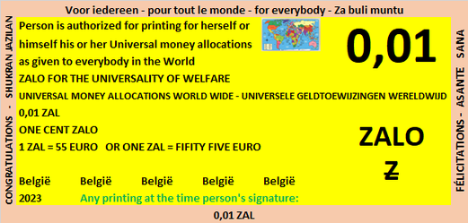

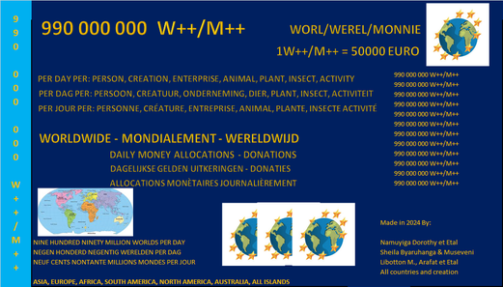

**Article 4: Objective and Achievement**

This is the goal and way of realization.

1. Design our capital with any material.
2. Verbalize our capital to anyone.
3. Give to each interest and interested party worldwide either a daily monetary allowance amount of 990,000,000 euro per day (nine hundred and ninety million euros per day) or its summary (by multiplying the same of 990,000,000 euro per day (nine hundred and ninety million euros per day) amount x (times) number of days and/or years) by any means or form of payment existing or created.

The recipients of the allowances are any person, any nature in its categories, any living being (such as an insect, an animal, a bird, a plant) or a non-living being (such as earth per 30 m², water per 100 m², stones per 2000 tons) for the purpose of meeting expenses or making any payments incurred in a given day or month or year or duration.

1. Write down the 990,000,000 euro per day (nine hundred and ninety million euros per day) in order to use this one as a means of payment and no other means at the real time or other amount simply written by our means available to us no obligation to look like another designer.
2. To design currencies and as many currencies as "ZALO", Worl-Werel-Monnie with the aim of using them as a form of money to make payments and never be blocked by these shortages.

Examples below: The images below will appear as currency in use by us on paper in use for images.

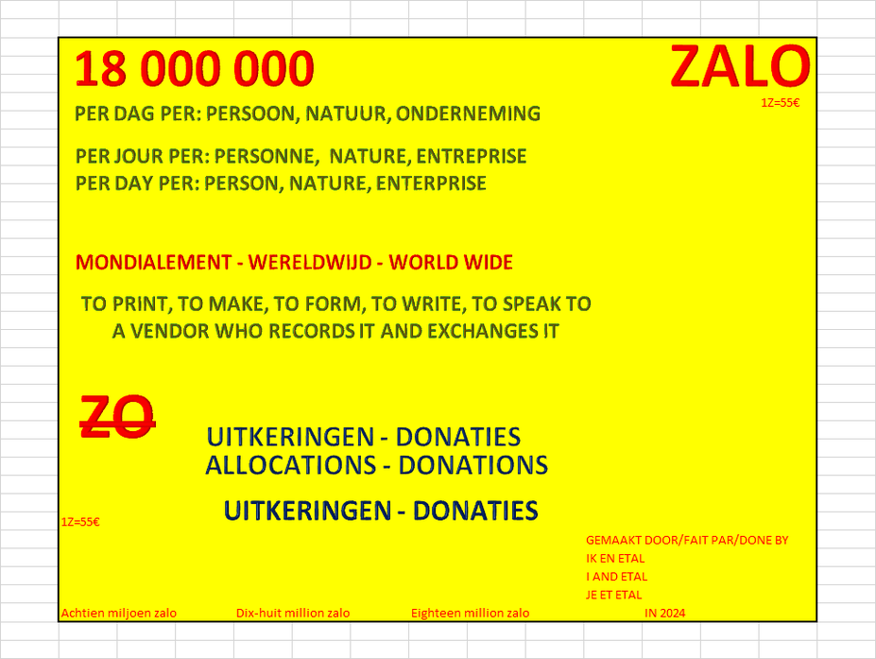





1. For our interest, everyone worldwide can design on a desired or desired material by adding an amount, a desired or desired currency name whether it is in use or not yet (this means that it invents a name and makes us known at the offices of these cooperatives to exchange them) and its full name or signature plus country.
2. Put books or paper or materials in columns in use as a means of receiving and making payments to one another. This is done in writing either by customer or by seller of services and goods or by client or by recipient of these donations by entering the amount receivable or payable in the appropriate column.
3. Below is a small but very long table in years without added value because it is just to receive or pay, not to justify a purchase or a sale, but to justify a payment for a purchase or a sale. So a copy of it will show an extract of the inflows and outflows of money or coins or writings for us here with the aim of paying each other, whether it is me or other.

|  |  |  |  |  |
| --- | --- | --- | --- | --- |
| **Numbering of entries** | **Dating entries** | **Receive my 990,000,000 euros per day or are summary of the year or years** | **Pay by writing with seller in front of me or on the other end of the phone or messaging here effectively** | **Describe what is actually received or bought or sold to receive** |
|  |  |  |  |  |
|  |  |  |  |  |

What will appear in the books to use to receive first of all 990,000,000 euro per day (nine hundred and ninety million euros per day) per day or other income and to use for payment for anything in store or at a supplier whatsoever. See the table to be reproduced to receive entries coming to the bookkeeper in his own name and again to pay for releases or purchases made by the same title of the book or his group or company.

**Article 5: Duration of this undertaking**

At open offices it will last for its hours indicated each day.

**Article 5: General Assembly:**

They are held every month.

Publish on 30 April of each year or before if the day is not working, the annual accounts of Belgium in summary and taking into account that the populations around Belgium have each received 990,000,000 euro per day (nine hundred and ninety million euros per day) x 365 days. And we close the deliver with zero.

We have the attention to fine to the person or nature or be that you receive 990,000,000 euro per day (nine hundred and ninety million euros per day) x 365 days this year and that's it.

**Article 6: How to pay to everyone and nature?**

We will pay by usable and saleable means such as filling your notebook with us or your table at the start. We will not accompany you to the seller but you can come with a seller so that each party can enter the outputs or inputs in the appropriate column to conclude your purchase or sale with each other. When you come here, look at where the amount received goes in and where the amount paid comes in, and that's the payment to each other

**Article 7: Management**

It is by the interested parties how they conclude contracts. We are designers and donors. Whoever wants to help us will contact us.

We design and we can exchange designs with each other all over the world.

The others must set their jobs in motion to achieve each objective day by day worldwide.

**Article 8: Directors**

We start with the one that is available and especially at the moment with Dorothy Namuyiga. If Namuyiga Dorothy does not have exchangers, she is entitled to the Public Social Allowance Center allowances forever.

All professions of different categories are welcome to work and pay themselves by designing themselves the 900 euros per day for their work, to establish the pay slip and to pay the social contributions and deductions for personal taxes.

Our services cost 5 euros per print from the beginning depending on the market.